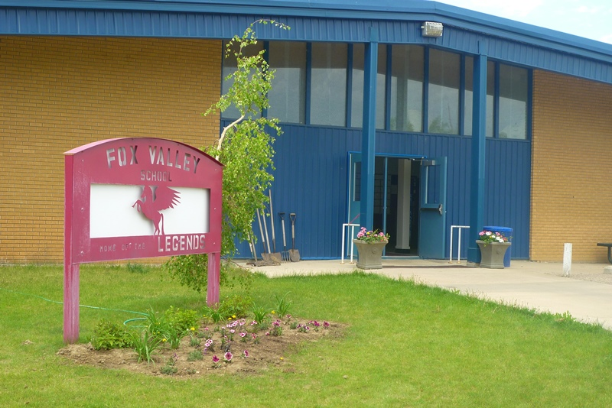
Fox Valley School Newsletter
January 2021

Fox Valley School
January Exam Schedule/Midterm

 | Grade 6/7 | Grade 8 | Grade 9 | Grade 10 | Grade 11 | Grade 12
Monday, January 25  Day 2 |  |  |  |  | History 30 (unit test)
Tuesday, January 26  Day 1 |  | Math 8 | ELA 9 | Science 10 | ELA 20 | Pre-Cal 30
Wednesday, January 27  Day 2 |  | ELA 8 | Math 9 | Math 10 | Health Science 20
Thursday, January 28  Day 1 |  |  | Science 9 | ELA 10 | Math 20

NO Open Campus for Grades 6-9
Open Campus Grade 11-12 Monday, January 25th – Thursday, January 28th
Open Campus Grade 10 Tuesday, January 26th – Thursday, January 28th

Please remember to call the school or make contact with your child(ren)’s teacher if they are NOT going to be at school!!! If we have not received parent contact regarding an absence, the school will make contact with you!!
Thank You!

What’s Happening In The Classroom

Grade 2/3 - December has been a busy month in the grade 2/3 classroom. Following the theme of Christmas, our persuasive writing unit consisted of creating a Christmas Sweater advertisement trying to convince the audience to buy it. In Art, we created beautiful snowflake ornaments that the student's are excited to hang on their trees at home! In Math, the grade 3's have started addition and subtraction with regrouping. The grade 2's are looking at finding missing numbers in equations and comparing numbers. In Social Studies, we have been learning about our community and communities close to us. We have researched different jobs within communities and even held a classroom career fair demonstrating our knowledge of different jobs we researched. After Christmas, we will be beginning our Liquids and Solids Science unit. - Miss Peers

Grade 4/5 - We have finished another willow book called Camp Average and are starting in on Too Young to Escape.
Our bookworm is becoming quite colourful with a new ribbon tied on each time a child finishes a level. Many children have finished, or are close to finishing, their second level. When we have 40 ribbons tied on, we will get a special treat.
In math we are returning to multiplication and division with larger numbers. Everyone is now working on the regular mad minutes and becoming more proficient at knowing their times tables. This will be a big help when we begin working with fractions and decimals. - Mrs. Hoffart

Grade 6/7 - I hope everyone had a wonderful Christmas Holiday! We had a really fun persuasive writing unit in December but this month we are taking a sharp turn and going to start reading some short stories and articles about the World Wars. Our focus will be on reading comprehension strategies and expository or factual account writing.
In Health we didn’t quite finish up our safety and first aid unit in December so we will be continuing that unit for this month. We have looked at staying safe at home, in school, and during activities and now we will focus on first aid and how to treat certain injuries. This unit has a short exam at the end so students need to stay caught up on their notes. – Mrs. Yeo

2019/2020 Yearbook
Last chance to get your 2019-2020 Yearbook!!!The cost of each yearbook is $50. If you would like one, please send a cheque made payable to Fox Valley School or cash in a well labelled envelope to the school.

LIMITED NUMBERS AVAILABLE!!!!!
Don’t be Disappointed!!

Mrs. Marsh’s Classroom

Hi everyone! January will be a busy month for everyone. The Grade 9s started their unit on Linear Relations just before Christmas and will be finishing it this month. We will be having an exam in January for Chapters 1-4. These chapters include Surface Area, Powers and Exponents, Rational Numbers, and Linear Relations.
The Grade 8s have started their Integer unit and are busy learning about the rules for multiplying and dividing Integers. The Grade 8s will also be having a test at the end of January focusing on the first three chapters we have finished. These chapters include Percents Ratios and Rates, Fractions, and Integers. In Science, the grade 8s are learning all about cells and their functions.
The grade 7s are continuing their math unit on Integers. When we finish this chapter, we will move on to Equations. Ask your child, what is an integer? When do we use them in everyday life?
The grade 6s are also continuing their math unit on Number. We have been learning about the difference between factors and multiples, prime numbers, and the Order of Operations! Their next unit will focus on Angles and Polygons. Ask your child, what is a Prime Number? What is the opposite of a Prime Number?

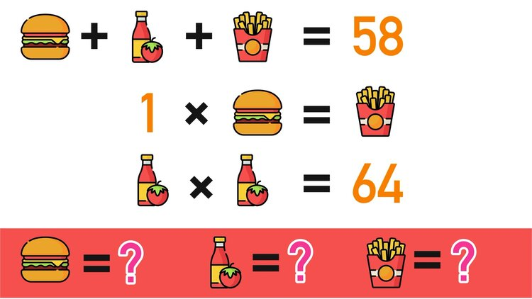

Miss Bakanec’s Classroom

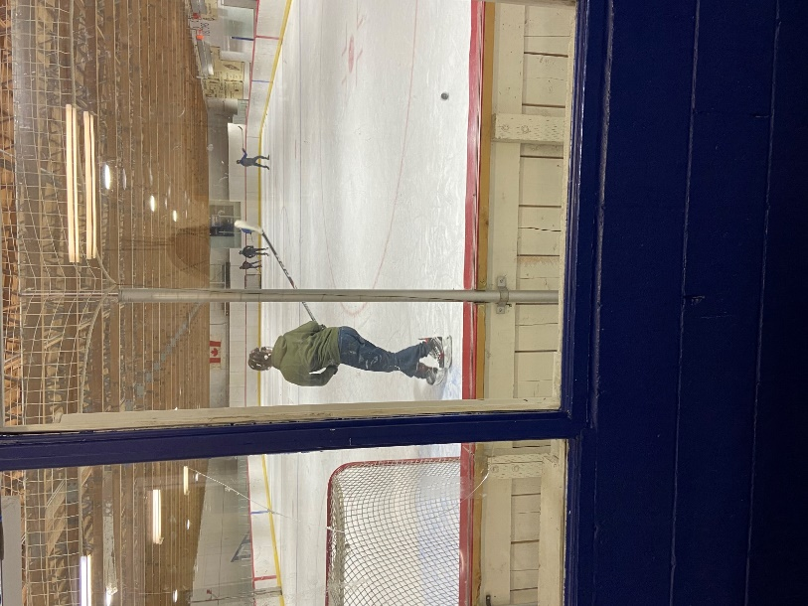
The Grade 10's have just completed reading the play "Dracula" and are now working on comparing it to the movie "Hotel Transylvania"! They have also been working on their coding program in PAA. Currently the class is working on web development. In Wellness 10 and Phys. Ed 20 the students have been taking turns going skating, they are loving it!
The Grade 11's have finished reading "Who Killed Jackie Bates?" ending with a class debate about who was at fault... The Great Depression vs. Jackie's parents. The class has now moved onto the play "On Golden Pond".
In Health Science 20 the class is wrapping up the Diagnostics & Treatment unit. The students will be doing a seminar discussing vaccinations in the classes to follow.
SRC
January Spirit Days
Wednesday, January 6th
Wear your hat & donate $1 to the Maple Creek Food Bank

Wednesday, January 13th
Moustache Mask Day

Wednesday, January 20th
Senior Citizen Day

Wednesday, January 27th
Western Day

Fox Valley SCC News
Welcome to 2021!! The Fox Valley SCC is staying active in the school by sending home another Family Bingo!!! Make sure to check with your child(ren) for a new bingo card for January!! We are focusing on the wellness of our families!

Next meeting is Monday, January 11th @ 7 p.m.

Dates to Remember
January 4th – Back to School
January 6th – Hat Day
January 11th – SCC Meeting at 7 p.m.
January 13th – Moustache Mask Day
January 20th – Senior Citizen Day
January 22nd – Subway
January 26th – 28th – Exams (refer to the Exam Schedule)
January 27th – Western Day
January 29th – Turn Around Day (NO SCHOOL for students)
January 29th – K-12 Report Cards will be post on the MySaskSchool Family Portal

